Computer Language Diagrams

Basic Diagram Elements
The diagrams are composed of only a small set of basic elements.

Shapes

6 basic shapes are used:

 | 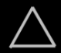 |  |  |  | 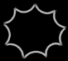
Circle | Triangle | Square | Diamond | Pentagon | Nonagon

Lines

There are 4 line types:

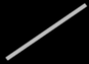 | 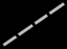 | 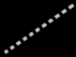 | 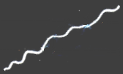
Solid line | Dashed line | Dotted line | Wavy line

Text

Diagrams also contain text. Shapes have names. Numbers and dates and other values also appear in the diagram as text.

My Object
My Site
7
3.141592
14-08-2005
"Hello"
True
False
On
Off
A = B + C

Custom expressions

Any kind of custom way to express an object can be embedded into the diagram.

Circles & triangles

Circles and triangles represent objects, classes and interfaces.
Objects can serve as prototypes for other objects. That way an object can serve as the class of another object. An object can also define the interface for another object. That’s why objects, classes and interfaces are all represented by the same type of shapes.

A triangle has a special function related to interfaces, that will be explained in another article.

Squares & diamonds

Squares and diamonds represent commands. A square is an inactive command, that only runs when you call it. A diamond represents a call. A diamond executes, a square does not.

Pentagons

A pentagon represents a globality. A globality is like a little world in which objects and commands live. A globality can be a site, a computer program, a library or other kind of module. A pentagon is considered an object just like circles and triangles, but a pentagon has a special purpose.

Nonagon

A nonagon represents collection. Objects can be placed inside the nonagon, to keep them grouped together. It is not required to draw a nonagon with exactly nine corners.

Object symbols

Circles, triangles, pentagons and nonagons are called object symbols, because they represent objects.

Circle | Triangle | Pentagon | Nonagon

Command symbols

Squares and diamonds are called command symbols, because they represent commands.

Square | Diamond

Solid line

A solid line represents an object. Object symbols connected by solid lines represent the same individual object.

Dashed line

A dashed line represents a definition or class. Object symbols connected by dashed lines have the same class.

Dotted line

A dotted line represents an interface. Shapes connected by dotted lines have the same interface, so that they look the same from the outside, but are different on the inside.

Wavy line

A wavy line represents a value. When shapes are connected with a wavy line they get the same value.

Object symbols drawn with different lines
An object symbol can represent an object, a class or an interface.

Each object can serve as another object’s class, thus functioning as its prototype. Each object can also provide the interface for another object, giving another object the same exterior, while it is different on the inside.

If an object is only used as an object, not as a class or an interface, it is drawn with a solid line.

But if an object symbol is only used as a class, then it is drawn with a dashed line.

 | 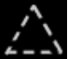 | 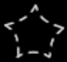 | 

If an object symbol is only used as an interface, then it is drawn with a dotted line.

 | 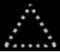 |  | 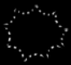

If object symbols are used in several ways, for instance as an object as well as other objects’ class, the symbol gets multiple borders. Here’s an object symbol that serves as both an object and a class:



That way an object symbol can have a maximum of three borders at the same time.

Theoretically it is not required to draw symbols using different lines types; you could draw them all with solid lines, but it just works more intuitive to draw a symbol with a different line type based on its usage.

Command symbols drawn with different lines
A call is always something that is created and instantiated when run, a command definition is always a definition, that is never created itself. In that sense a call is more like an object, and a command definition is more like a class.

If you draw the command symbols with a line type conforming to their usage, then diamonds, that represent calls, would always be drawn with a solid line, but squares, which represent command definitions, would always be drawn with a dashed line.

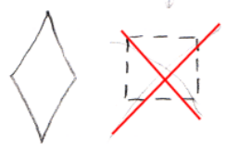

But a square already clearly defines that it is a command definition, so drawing it with a dashed line is not necessary to further denote it is a definition.

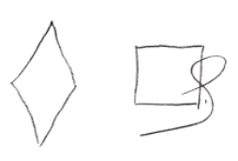

This does not mean, that you could also simply abolish the diamond shape, and only use solid and dashed squares to represent the difference between a call and a command definition: using different line types is only an extra. The diagram should be able to express things unambiguously without using different line types for shapes.

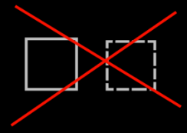

A diamond, which represents a call, can be used as a command definition, but this is not common for a diamond. In that case a diamond gets both a solid border and a dashed border, indicating that is it both an instance, and a definition.

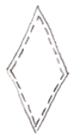

Both command calls and command definitions can function as the interface for another command symbol. In that case the command symbol gets an extra dotted border.

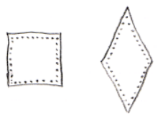

A square can also function solely as an interface for a command. In that case it is drawn with just a dotted border:

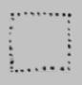

There is an exceptional case where squares are drawn with dashed lines, but this is explained in a section further down.

Connecting object symbols
Object symbols can be connected by different types of lines.

If two object symbols are connected by a solid line, it means that both symbols represent the same individual object.



Lines do have a direction, going from one symbol to the next, which will be explained later. Having a direction, an object line points out which object an object symbol will represent. The solid line is called an object line in this case, because it points out the object.

If two object symbols are connected by a dashed line, it means that both symbols have the same class, which means they have the same behavior, but are not the same individual object.



Lines do have a direction, going from one symbol to the next, which will be explained later. A class line points out, what class an object has. The dashed line is called a class line in this case, because it points out the class for the object.

If two object symbols are connected by a dotted line, it means that both symbols have the same interface, which means that they look the same from the outside, but are different on the inside.



The two symbols are separate individual objects, they also have a different class, so behave differently, but from the outside they look the same. Lines do have a direction, going from one symbol to the next, which will be explained later. An interface points out the interface of the object. A dotted line is always an interface line.

If two object symbols are connected by a wavy line, it means the objects get the same value.

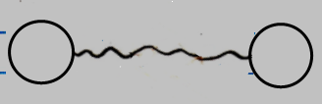

It is always about transfering a value from one object to the next. Later the expression of the direction of the line will be described.

Connecting command symbols
Command symbols can be connected by different types of lines.

In theory, a call line should be dashed, because it points to the definition for the call. But when you draw a call line with a solid line, it is clear enough you are pointing out the definition for the call. To keep the diagram simple, the definition line for a call is simply drawn with a solid line.

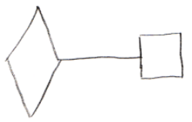

When command definitions, squares, are connected to eachother, it should in theory also be done with a dashed line, because it makes them represent the same definition, not the same individual call. But it is already clear, that only the definition of the two symbols is the same, so you don’t use the dashed line, you just use a solid line.

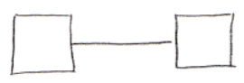

So a solid line between command symbols is always a definition line.

There isn’t much use to letting two diamonds represent the same individual call to a command. So you would never need a solid line to let two symbols represent the same instance of a command. That’s why the solid line can always be applied for pointing out the definition of a command symbol.

Two commands can have the same interface, which means that one command has the same parameters as the other command. Command symbols that have the same interface are connected using dotted lines:

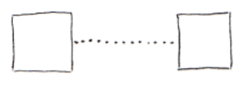

A dotted line is always an interface line.

Commands with dashed lines
In the sections above it was explained that command symbols and command lines are never drawn with dashed lines.

However, in a special case they are. When drawing out the diagram in the way explained above, the class structure of a module is drawn out with dashed lines. To also draw out the command structure with dashed lines, the target definitions of commands are drawn with a dashed line. What a target definition is, is explained in another article

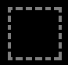

Also, lines that connect commands to classes are drawn with a dashed line. How commands and classes are connected is explained in another article.

It makes all structure elements and their relations drawn out with dashed lines. It’s more intuitive that way.

Line direction, access marks, line ownership
A line has a direction. The direction of a line can be explicitly expressed with an access mark:

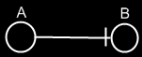
→

The direction goes from symbol A to symbol B. The access mark is placed right before the object, that is accessed.

But access marks are not always displayed. If you can derive the direction from a few basic rules, then an access mark is not displayed.

The first rule for line direction is that a line usually points outwards.

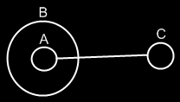
→

Symbol A has a line pointing to Symbol C, because lines tend to point outwards.

If the direction is not outwards, then you have to denote that with an access mark.

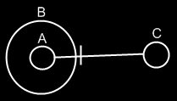
←

Symbol C now is a pointer to symbol A.

The second rule for line direction, is that a call is more likely to redirect to the command definition, than it is for a command reference to redirect to a call.

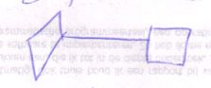

→

The diamond points to the square, because it is more likely for a diamond to redirect to a square, than it is for a square to redirect to a diamond.

If the direction is the other way around direction the other way around, you will need to use an access symbol:

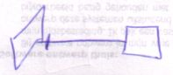

←

Access mark placement
When a line crosses symbols’ borders, it first exits borders and then enters borders. It’s impossible to mix exits and entries.

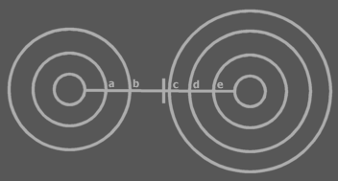
First come the exits a and b, and then come the entrances c, d and e.

If an access mark is drawn to denote direction, it is by default put in the section between the exits and entrances. So not neccessarily close to the eventual symbol pointed at. In other words: the access mark is usually put in front of the border that is first entered.

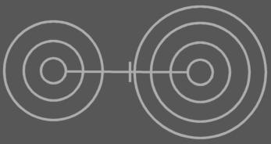

If the part of the line between exits and entrances goes out of view then the access mark can be placed where it’s still visible. It is placed in front of the last border in view that is entered or exited:



Don’t draw it like this:



because then you’re suggesting the other direction. Place it in front of the last border in view that is entered or exited.

Line ownership
An object symbol can only have one object line, one class line and one interface line. The lines point away from the symbol. They denote which other symbol is its object, which other symbol is its class and which other symbol is its interface. Any other lines connected to an object symbol point at the symbol, not away from the symbol.

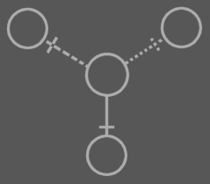

It works the same for commands, except that they have different line types. A call can have one call line and one interface line. A definition can have one definition line and one interface line.

A line never gets a name. They are always called, for instance: ‘the object line of symbol B’.

Line merge
Sometime two lines are so closely related, that they merge together to one line. This is called a line merge.

The lines in the following diagram are very closely related:

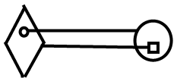

They merge together to one line:

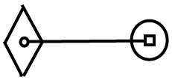

Lines merge together under different circumstances, that will come to light in later articles.

Symbol merge
A symbol merge is closely related to a line merge.
In the following diagram:

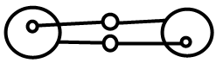

The lines and the symbols in circles the lines merge together:

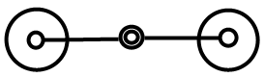

The circles merging together is called a symbol merge. When this is applied will come to light in later articles.

Author & Copyright: Jan-Joost van Zon Date: May 19, 2008 – June 19, 2008 Location: Oosterhout, The Netherlands Status: Finished

